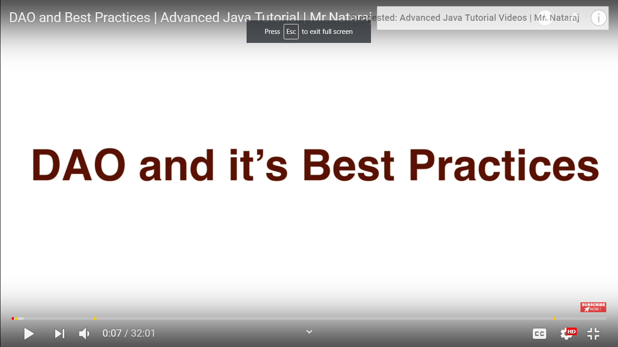

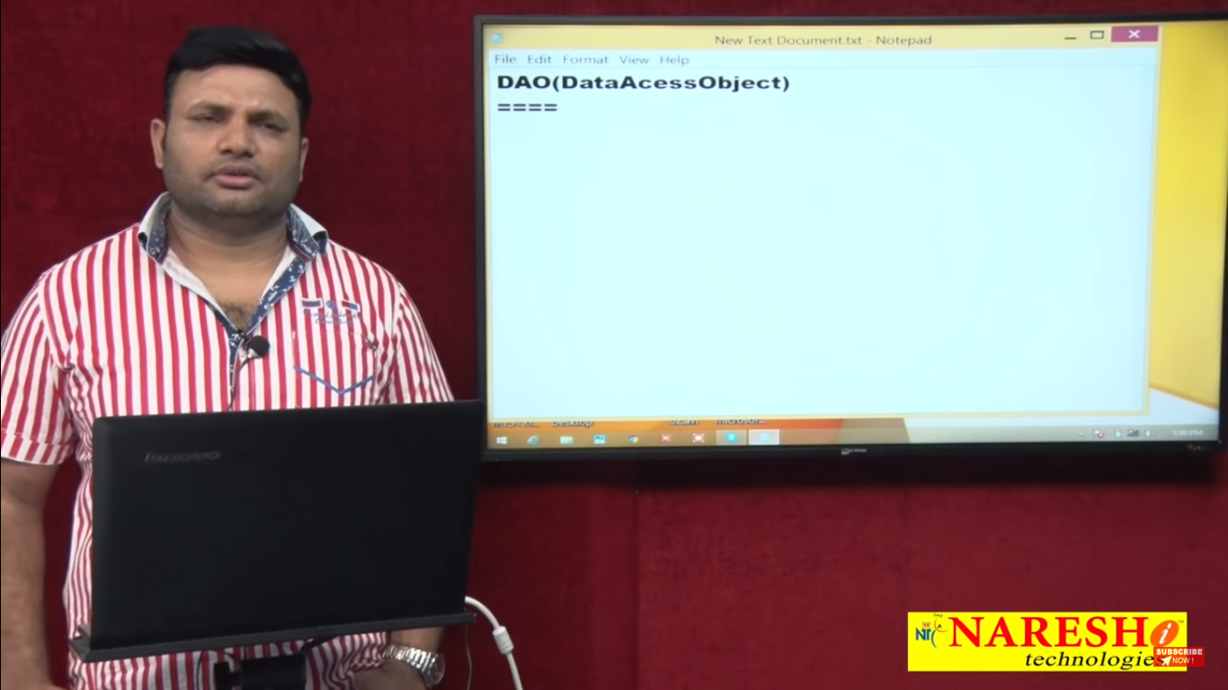

Note : Main work of deo is making persistence logic separate from other logic of the application and reusability of logic in multiple component of the application and flexibility of modification though we are changing this component other logic should not be effected.

Note : To development of deo we required multiple component .

Q: How many deo can be defined for an application?

A: Generally Industry follow two strategy

1. Per table Per Deo if no of table less(Ex less then 100)
2. Per Related table Per Deo of no of table is huge no because managing deo would be complicated

Note: Deo class is helper class of service class(where business logic are available)

Note: If Deo return one value then fine to have one return , but if more then two value would return then we will return value to service class with the help of BO(Business object).

Note: Generally Service and Deo layer is called is as Business tire component , how data is sent to service to deo is form of BO and how data is back pass from deo to service is BO

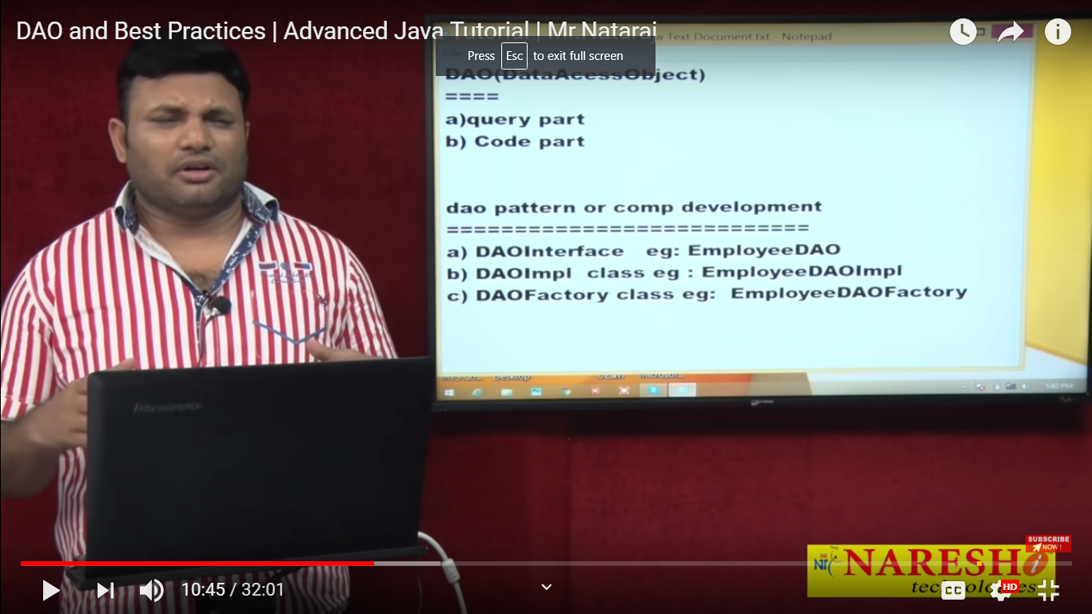

DAOInterface : Its contain declaration of persistence.

DEOImp: Its implementation of upper interface with persistence logic

Deofactory: Its contain logic to create and return deoimpl class object

Q:why required Deo interface?

A: Because we are using Deointerface as refrence in Service class so in future if deoImpl will change with any name or or we created many no impl class ,there is no problem that powerful its

Q: why required Deofactory?

A: Deofactory simple return Object of Impl as per requirement, so client(Service class) list bother about the implementations

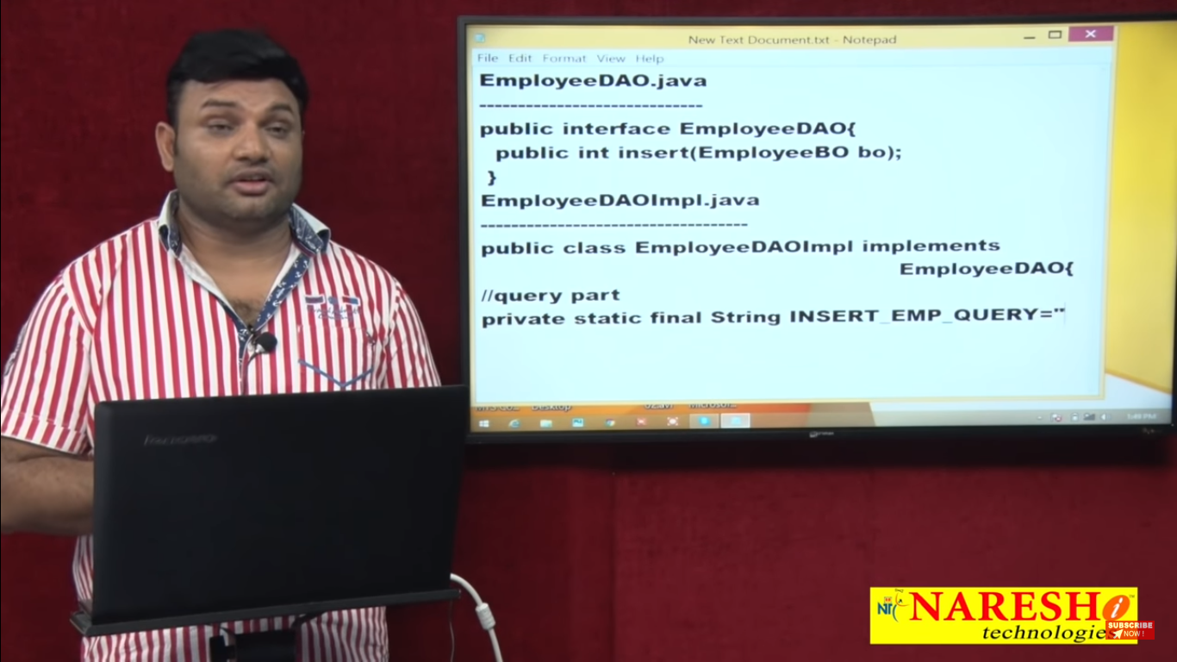

Note: See above be use BO class for more then one return value, and in query part we are using private because be have to use this value in this class only, final its recommended to use and we know final variable name will be upper case and query you need to use always in uppercase

Not recommended to use * value in query.

Q:Why we placed query on top of ?

A: suppose if you place your query in middle in persistence method so in future if table column change or table name change then its very difficult to find the method and change the query

Suggestion : when you start DeoImpl Class always make private final schema,table name and coloumn name at top ex:

**private final** *SCHEMA* = tokenDataSourceTemplate.schema  
  
**private final** *TOKEN_TABLE* = **"TOKEN"  
private final** *TOKEN_ID* = **"TOKEN_ID"  
private final** *CLIENT_CODE* = **"CLIENT_CODE"  
private final** *MAX_REDEMPTION* = **"MAX_REDEMPTION"**

Query part :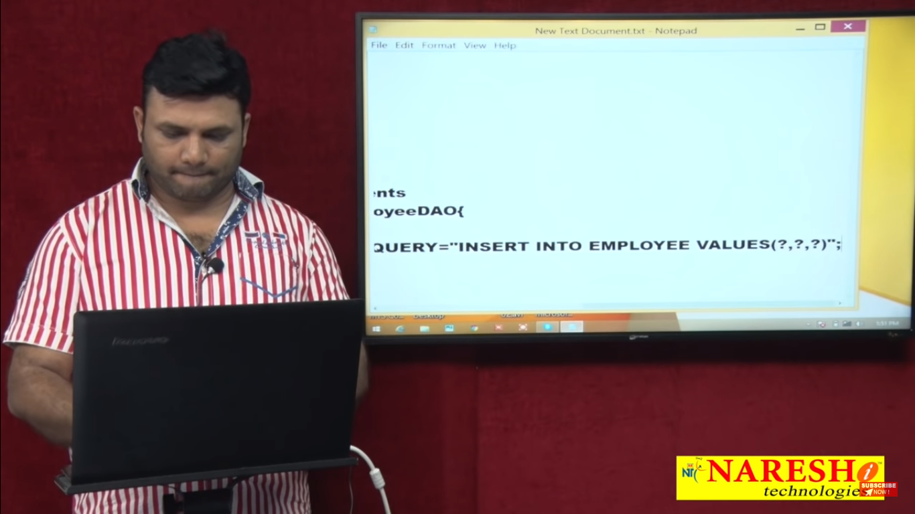

Logic part(code part):

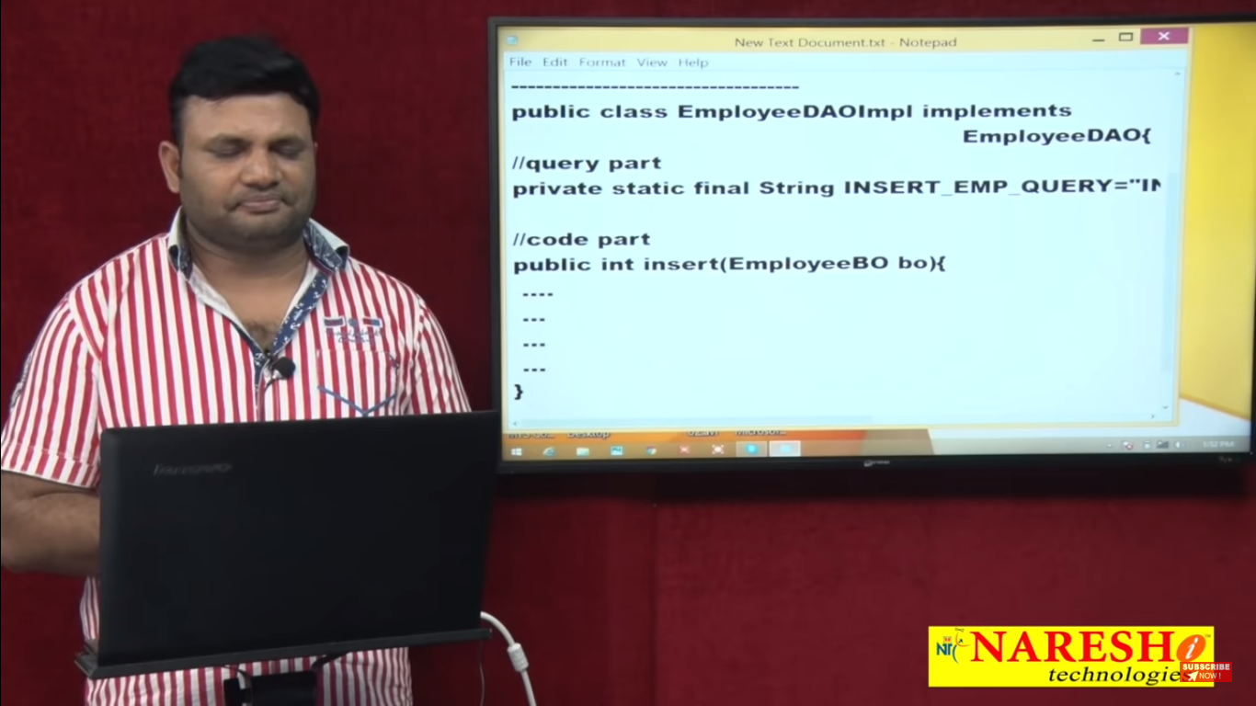

Note : You should never ever use exception here its not recomanded becouse you are supracaing and eating(propogation nature) a properites exception so it should be thrown from here,

And also you need not to handlle these exception from serice side and declare thrown to next level, handle this controller by using **rd.forword** forword these excpetion on in seprate error jsp page because

Excaption always consider as non technical.

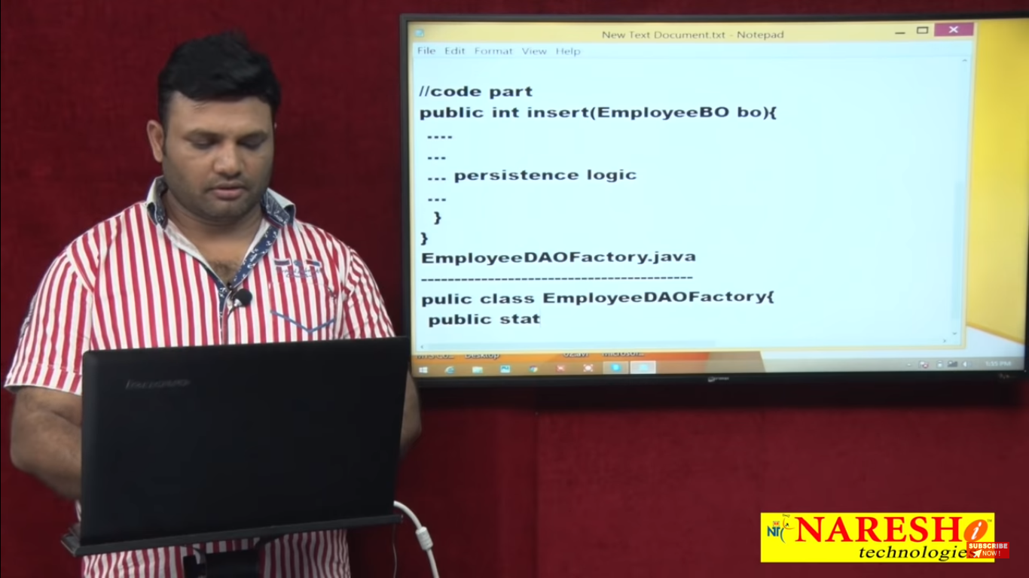

Factory method :

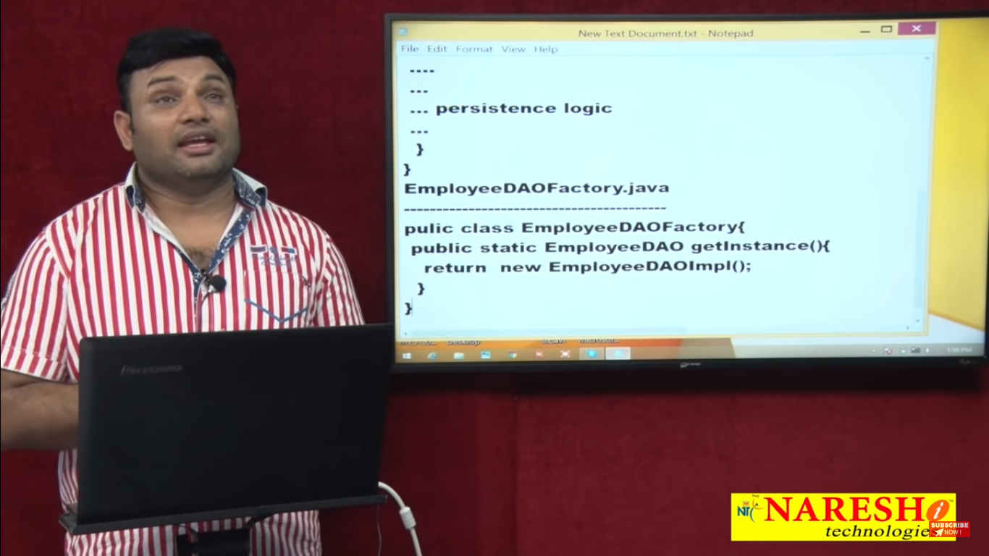

Always declare as return object as interface so any implimantaion you can return it.

Note : How we can utilize these factory inside service class

Note : Y required BO object any how we are getting dto Ans is we may get some other extra details which not required in percitance logic so need to create difftrent object which is BO

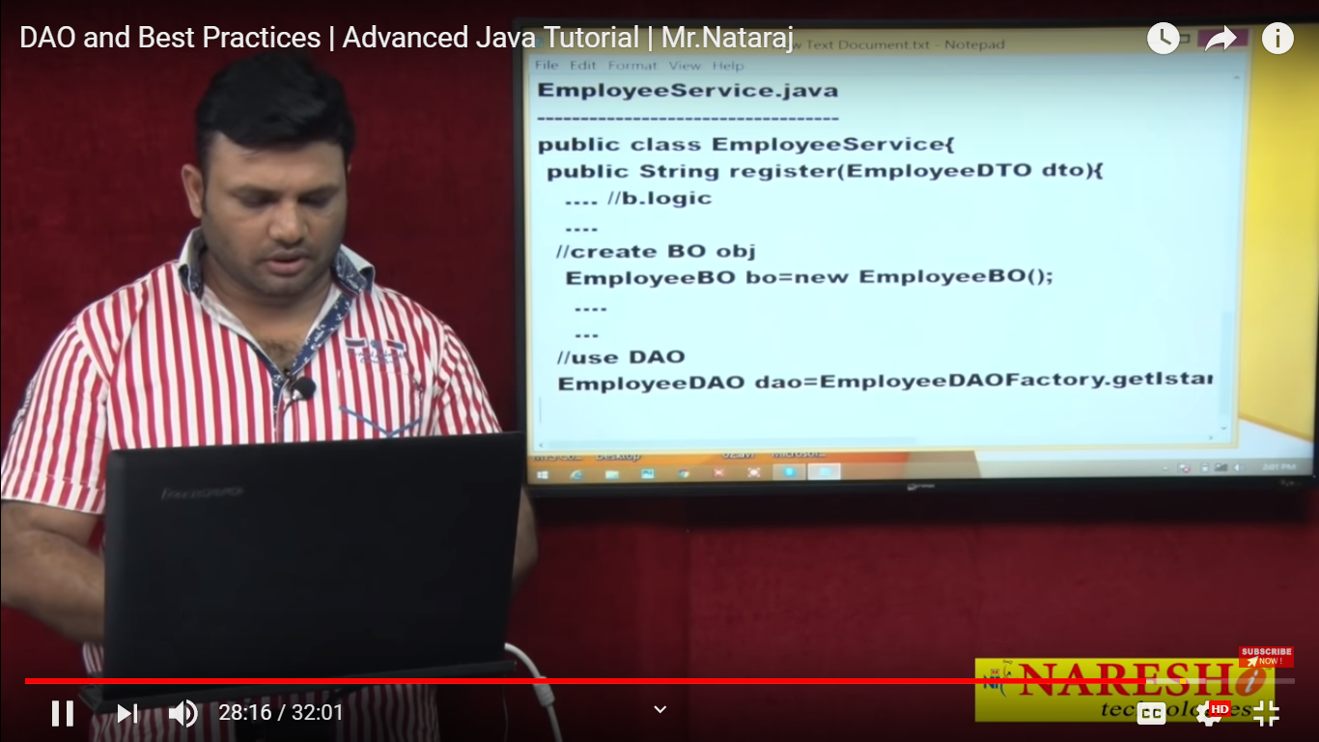

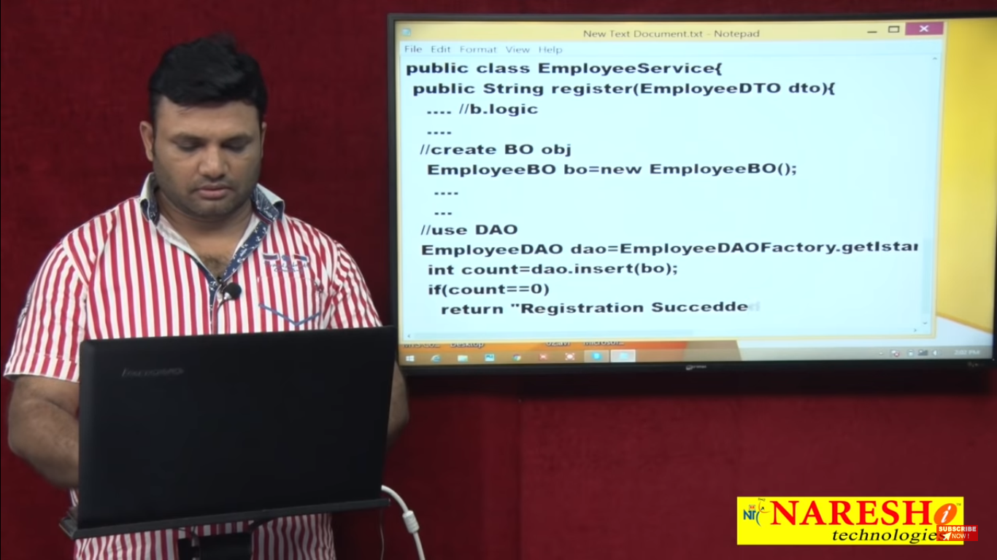

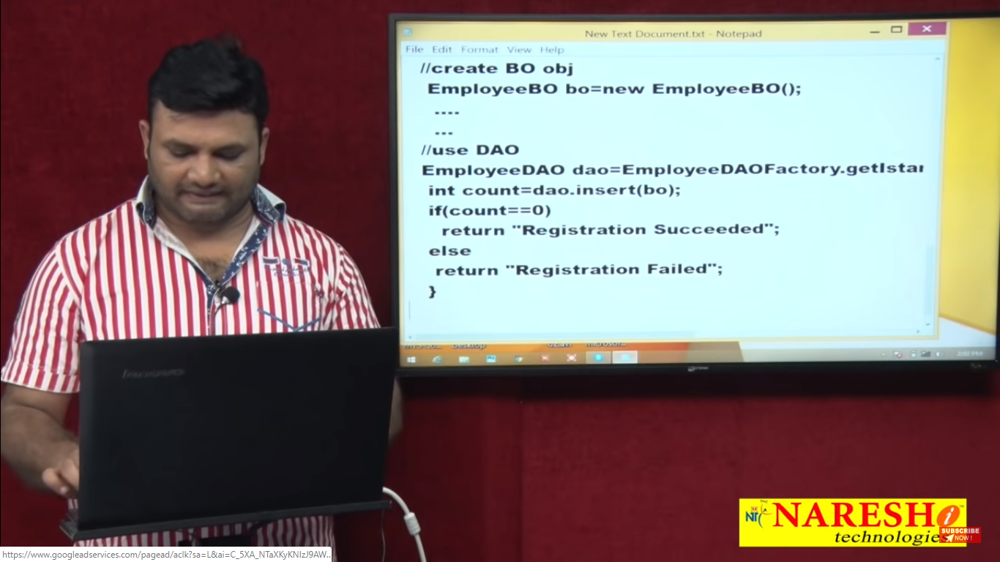

[Java Bean and It's Utilization in Real-Time](https://www.youtube.com/watch?v=io2TciOcF2Y)

[**https://youtu.be/GdPlNvPyvqo**](https://youtu.be/GdPlNvPyvqo)

**Java Bean is** java simple java class which has some recomandation:

* Java bean must be public for globaly visiable
* Its recomandation to make serialazable
* Every member variable should be non static private and getter setter
* Bean class zero arg cunstruct should be placed dirctly or indirectly (JVM place)
* Genrally we are using java bean to data to one component to other component becaue of that its recomanded to use serlization

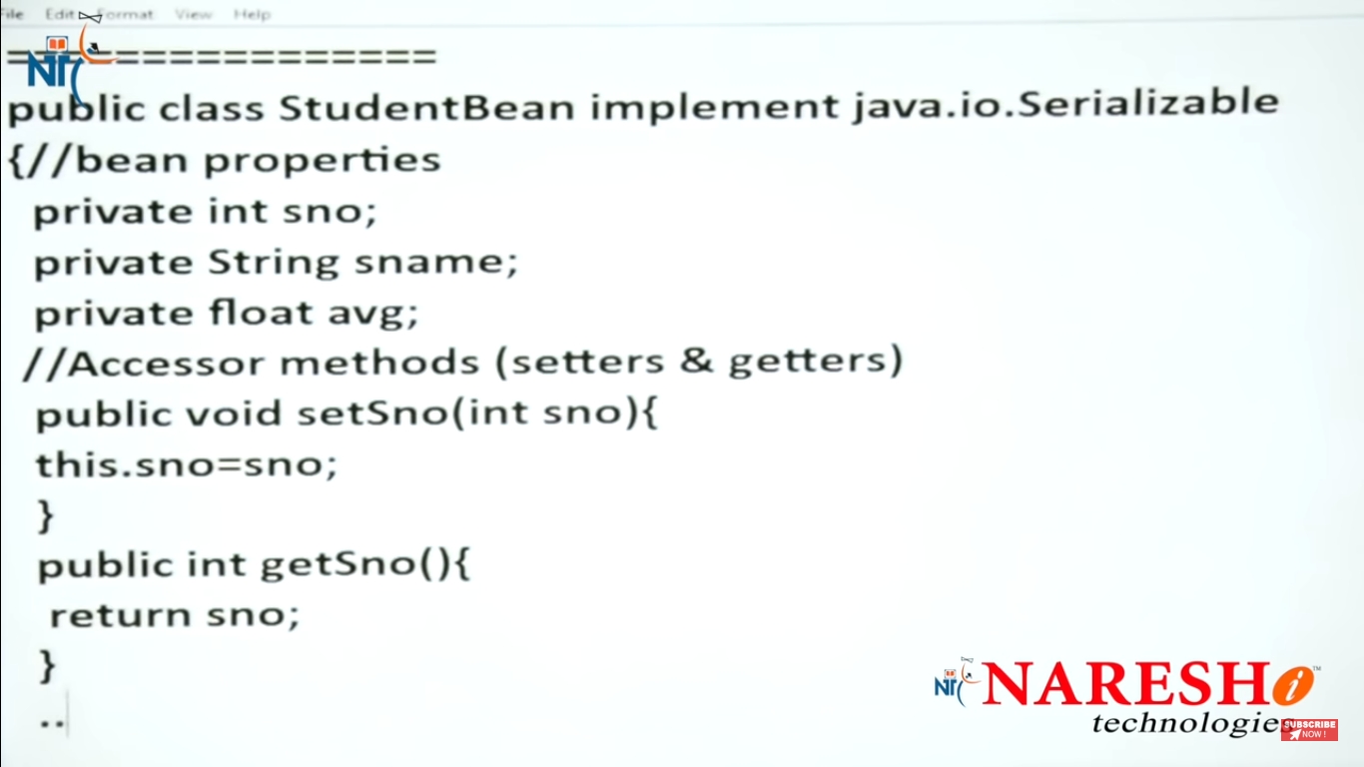

**Note:** Implmented Serialazable

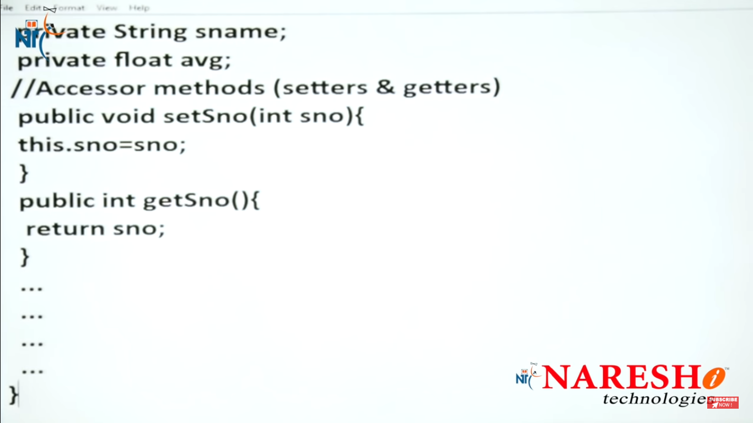

**This class is java bean**

Role of java bean : To passing data object in one component to other component

**Note :** Imp recomandation don’t create method with more then three parmeter because program get ride of confusion and mannaging its not good practice

Note : Because of not using more then three parameter to get ride of this problem we can use bean class , other wise we have to sent more then 10 parameter to fullfil our requirement.

Problem to not using JavaBean :

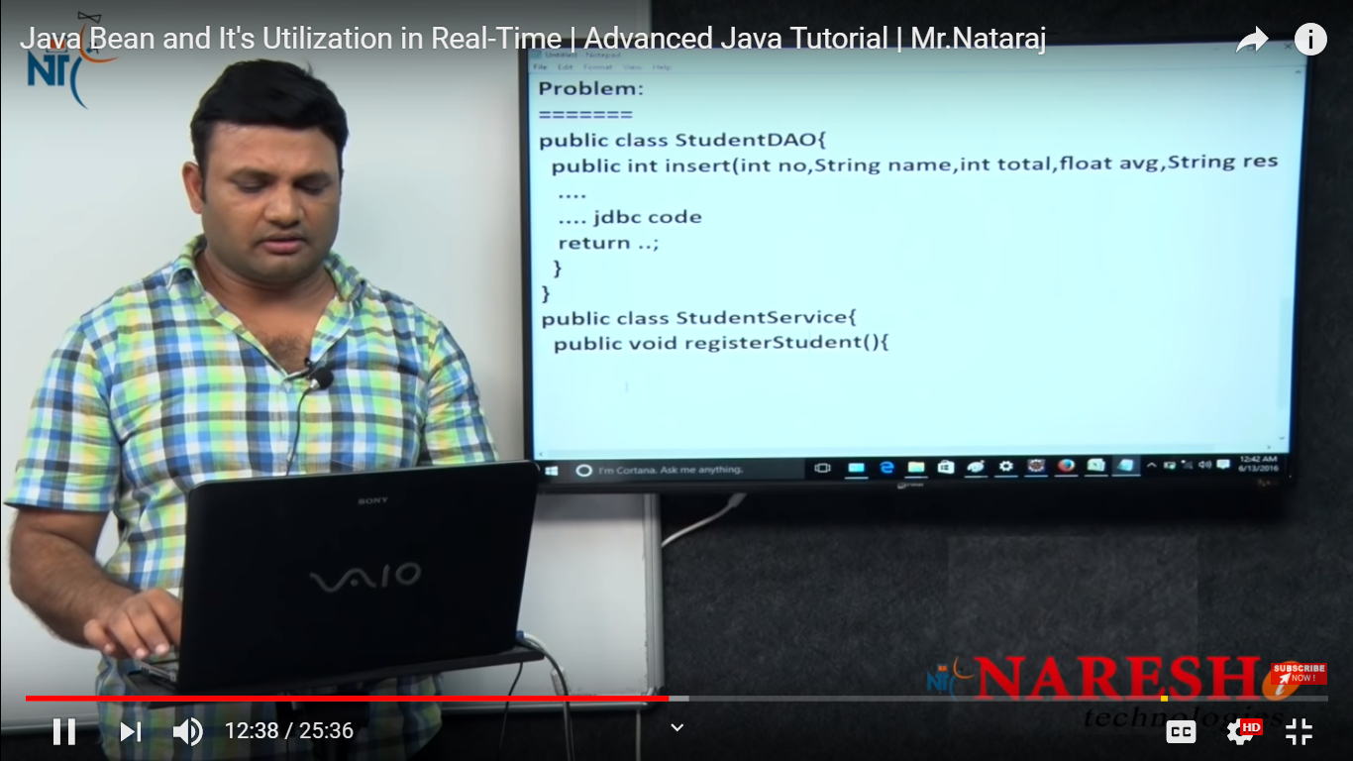

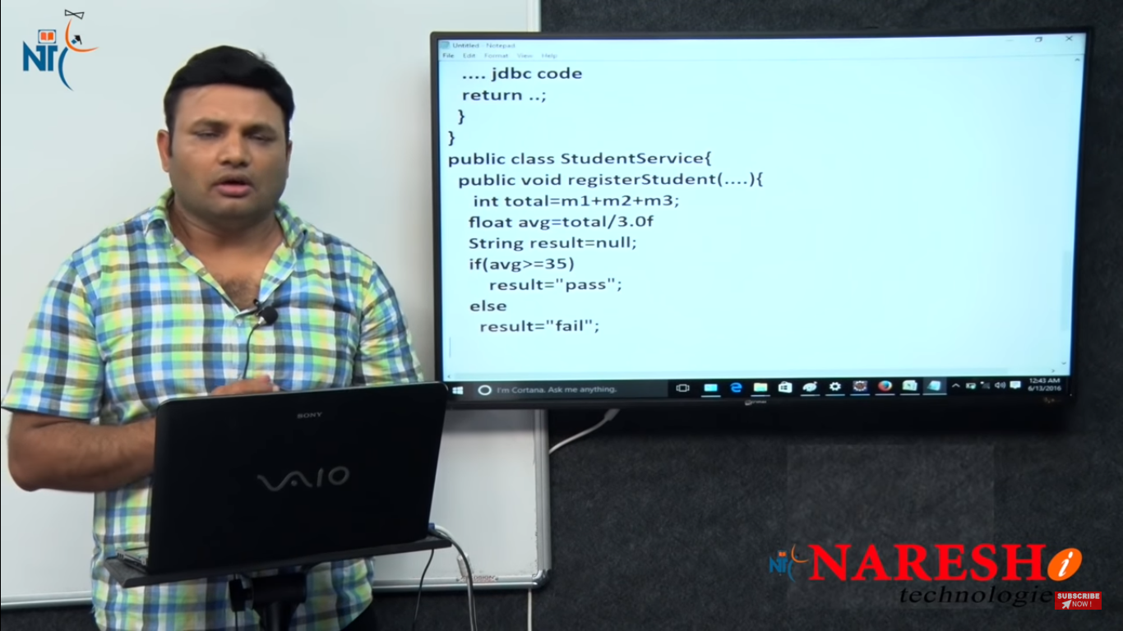

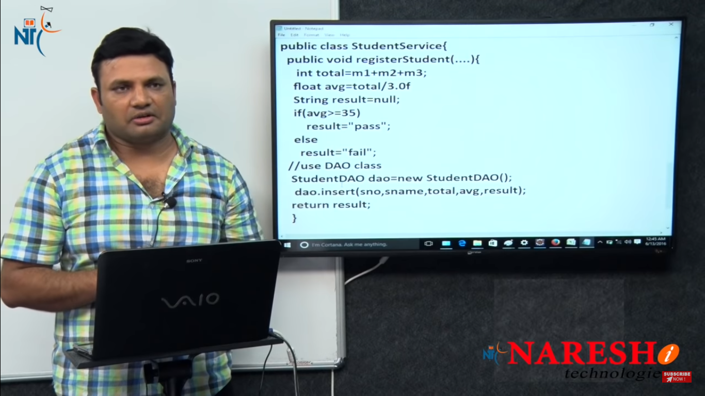

Note : Desing method more then 3 parameter is not good here other we may forgott order of parmeter type of parmeter its very confusing ,if you are going to change you may confuse but in bean easly find and change easly

**Solution for that :**

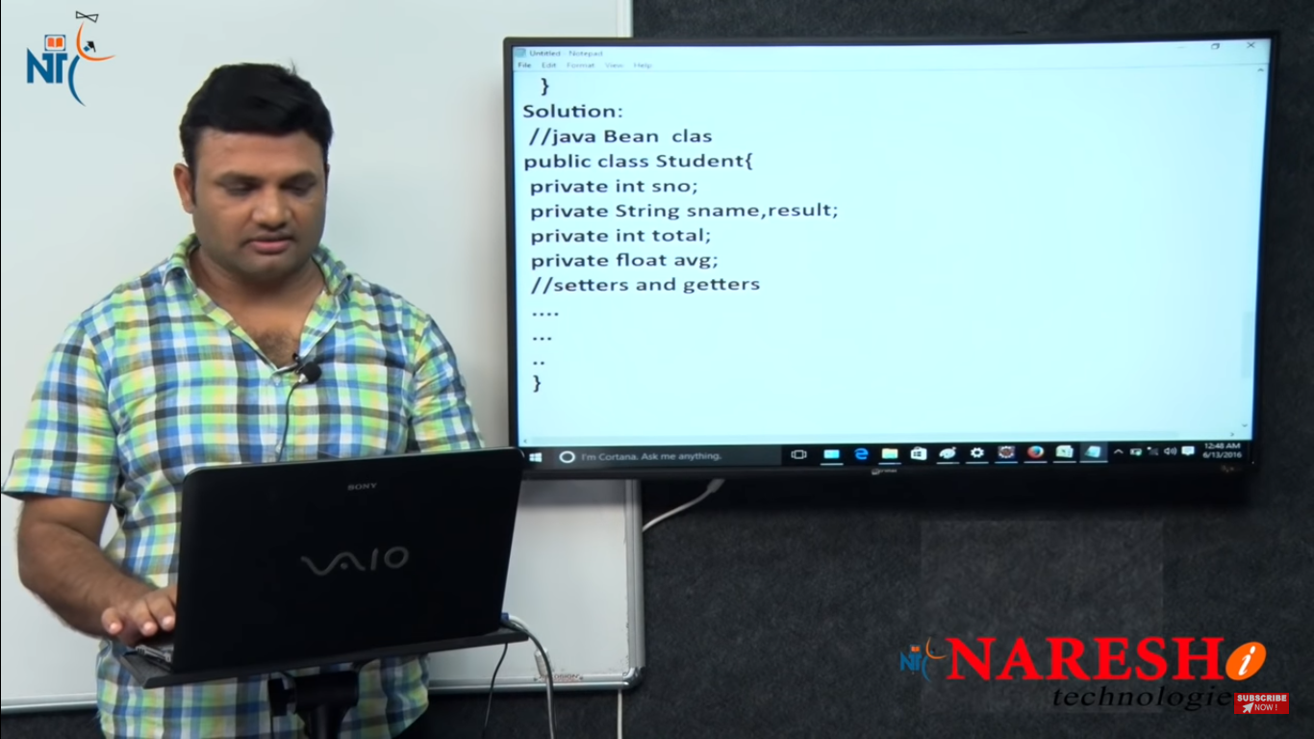

**Desing DEO :**

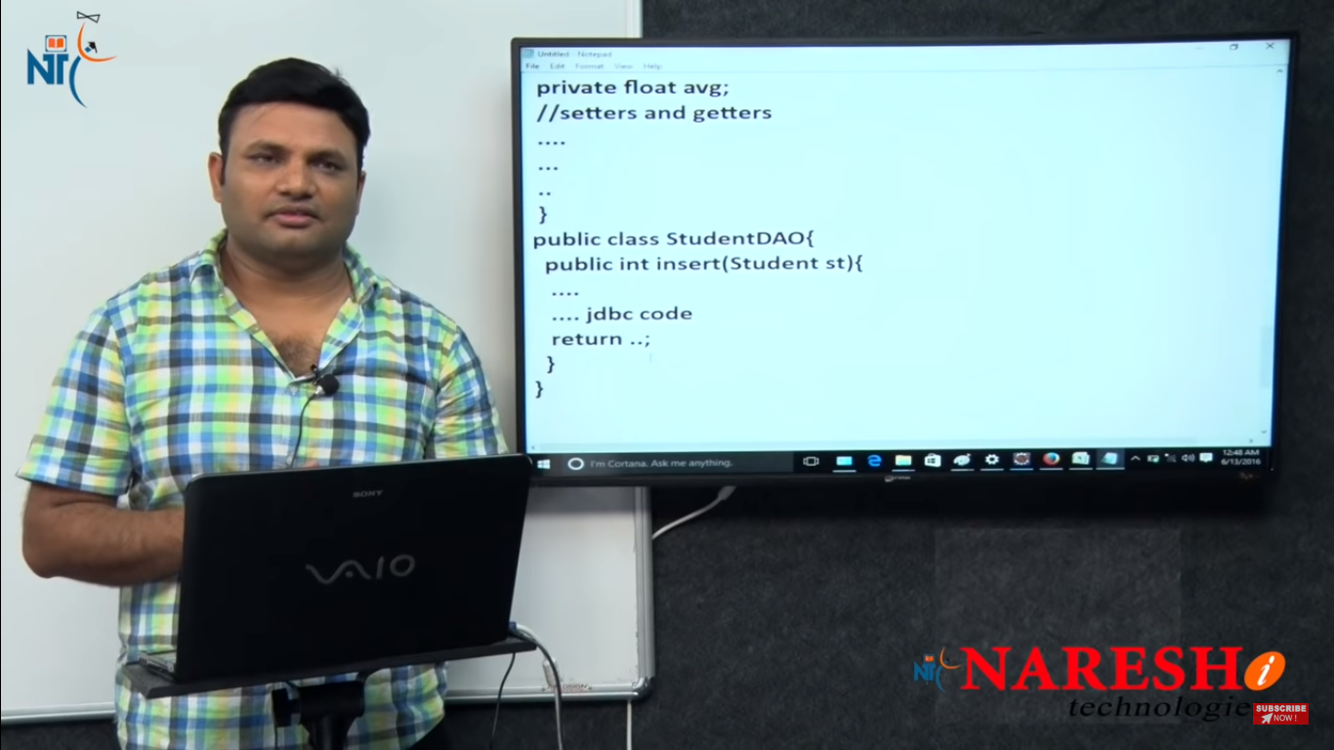

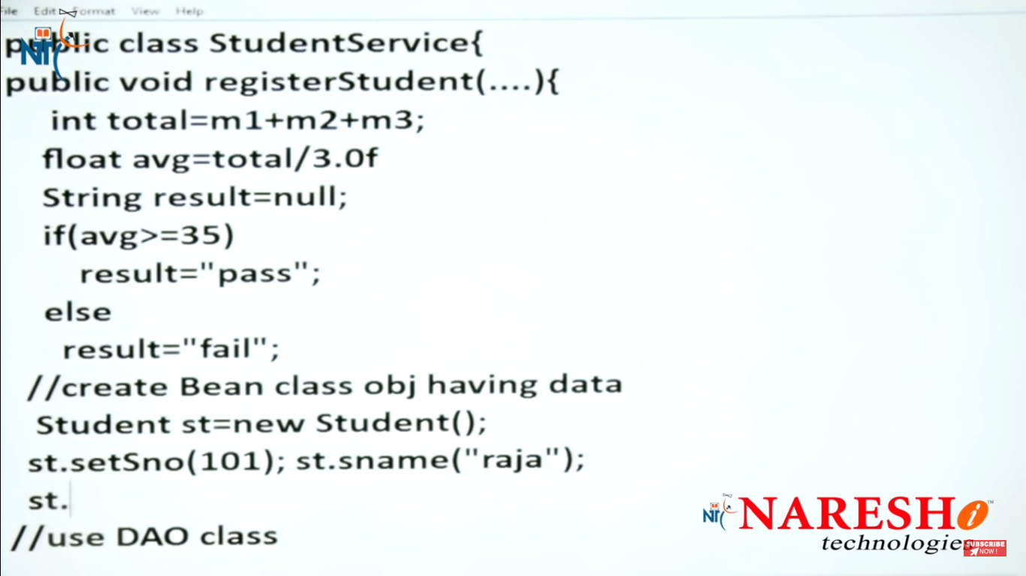

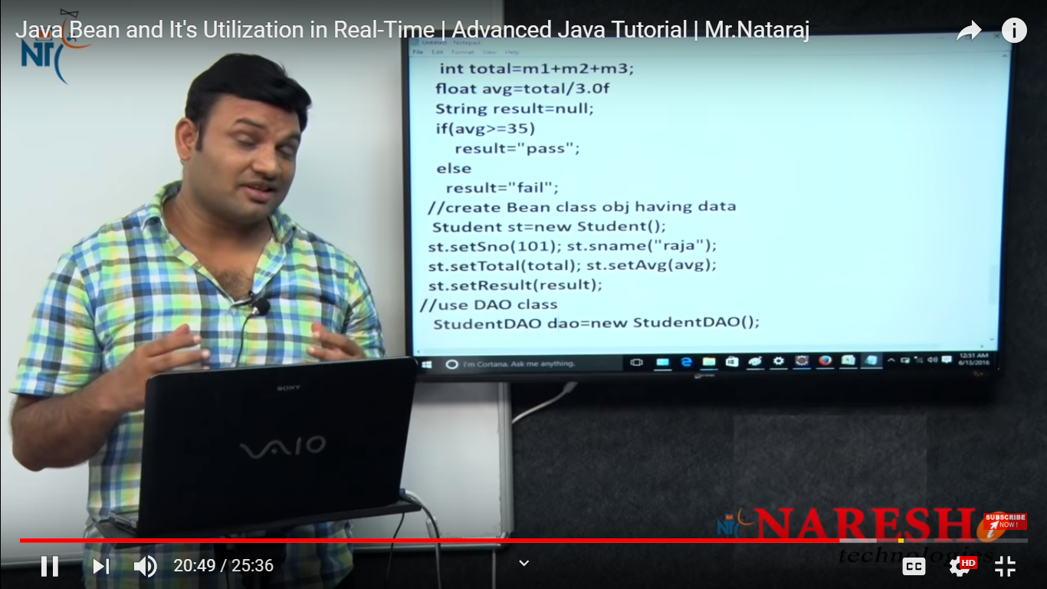

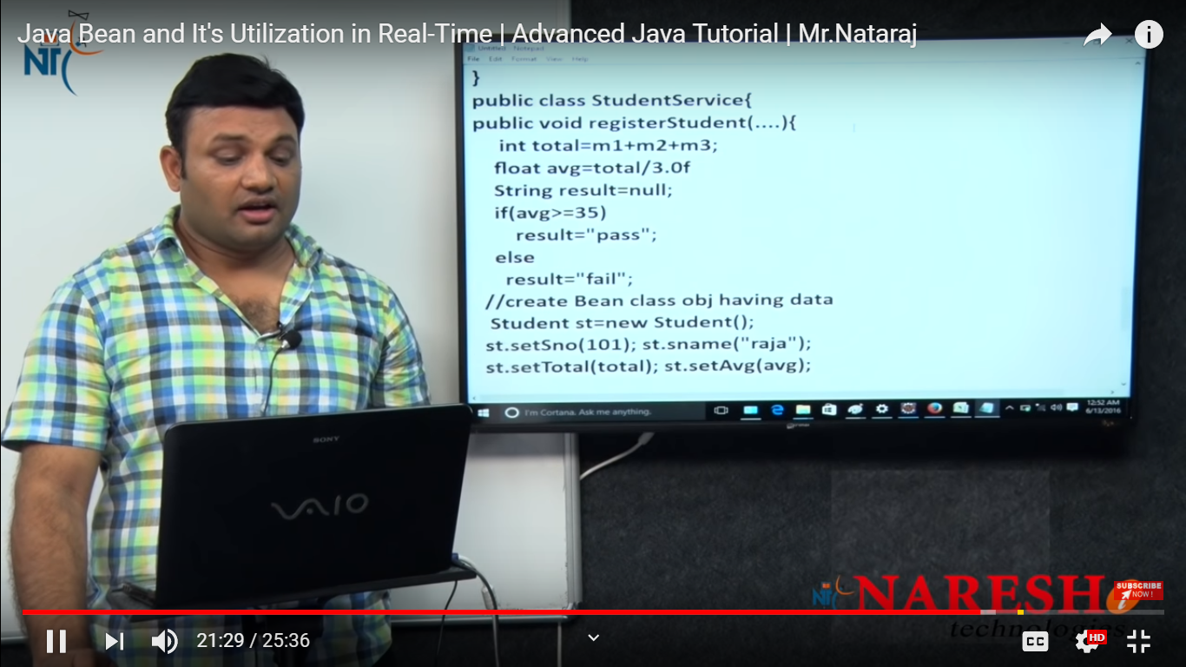

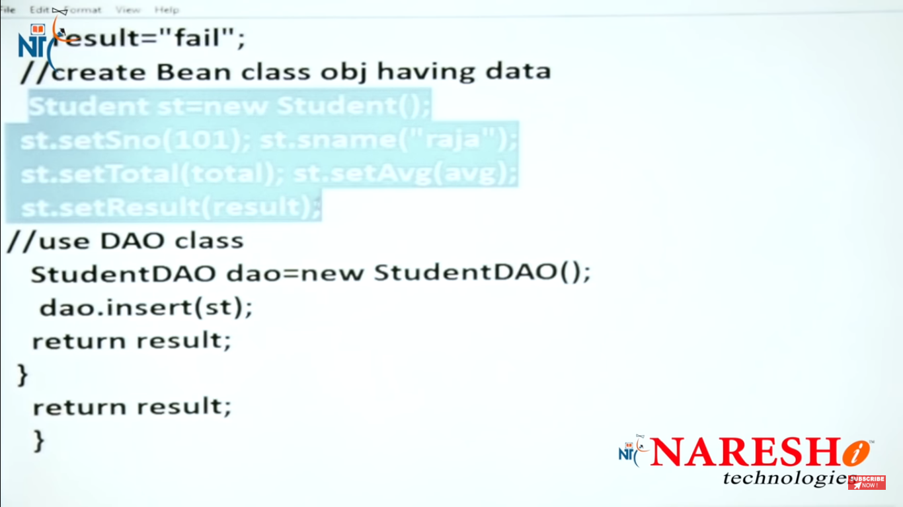

**Note :**  One agenda is only for get ride of more then three parameters

Method and make call light waight

**:Vo Class Vs BO Class Vs DTO class:**

**Based on data hold this java bean we have some name of java Bean(Based on kind of the data they holdes)**

**Value Object(VO)**

**Bussness Object(BO)**

**Data transfer Object(DTO)**

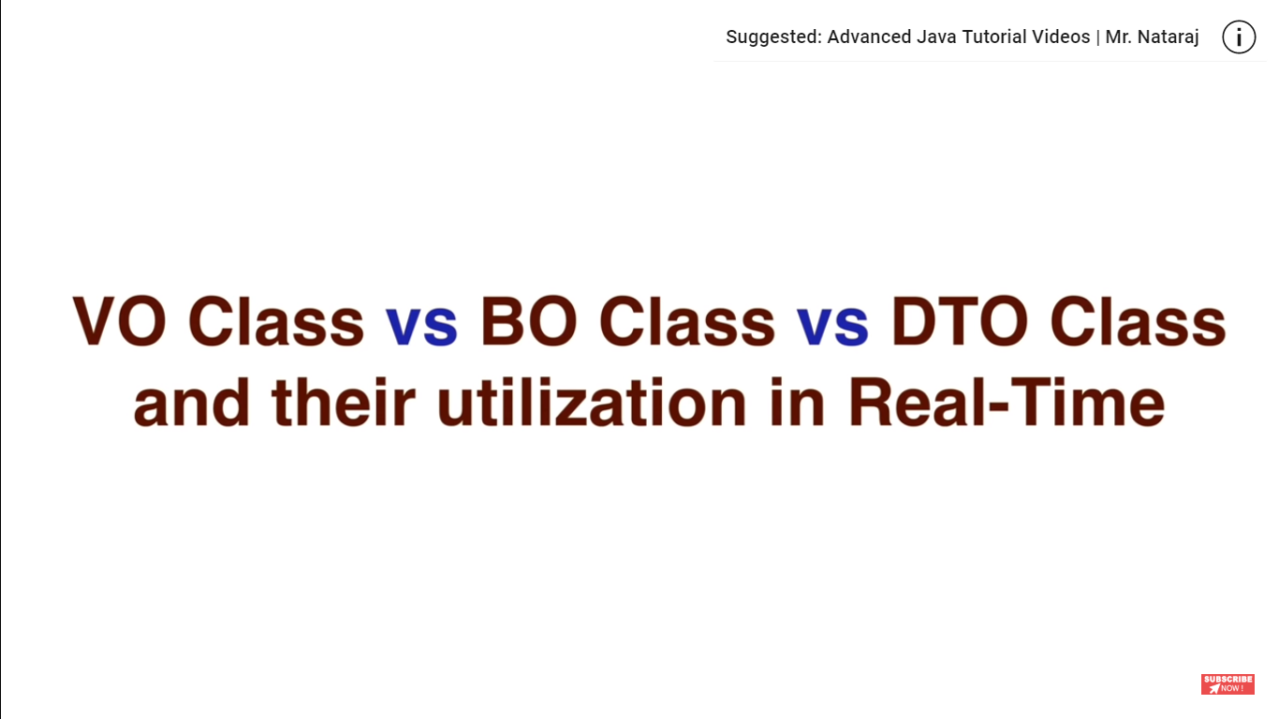

**VO Class:** the java class are the java bean that hold input value of objects or out put value which display to the applications is call as VO Ex : Input value is form value , output genrated process

* VO class mendained in String properties in VO class even no also if required later you can change to string to integer (this for only input data which is directly coming from user to applications)
* VO output also string proprtices is best practices
* Its suggested take class name is VO

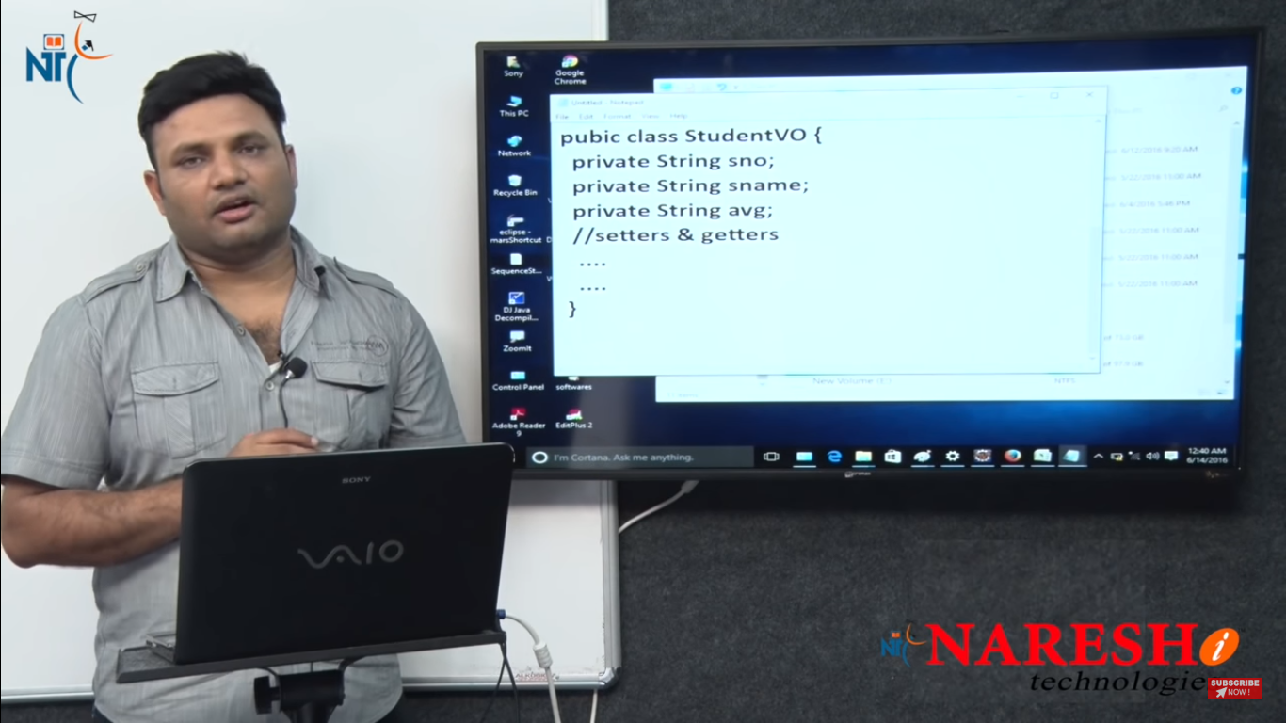

All are in string

**DTO Object :**

Java bean is very us full send bunch of attribue in one single object to other component

So data transfer object

Because of that transfer object it should be implement serilizable interface and this mainly use to transfer data to one component to other component with or without network

* This bean can conatain any kind of any type of attribute string,int …etc
* We are using this bean to pass object to controller to service class
* If web application want to send some data to outer side component

ex web application to EJB so you can use DTO

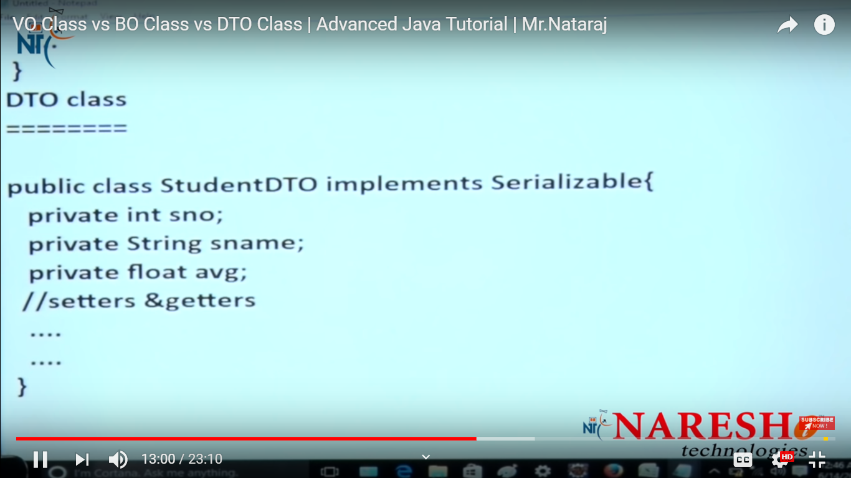

**BO Class(Domain or Entity or persitance class) :**

The java class object which data need to persistance as revers also true if some recods fecth from DB and store on java bean that also called as BO class

Note : This class property and data base colomn must be compatable

Becouse it going to persitance and getting properties from DB need to hold

Comptable types.

Note : We are going to use select query and we will get result in Result set we can send that object back to service class but its not good practice because this Resultset Object very specific to Data base object so we need to first create BO object put the value from Resutl set and send back to Service class or another layer

Example :

For Incoming data from DB no need to serliazable.

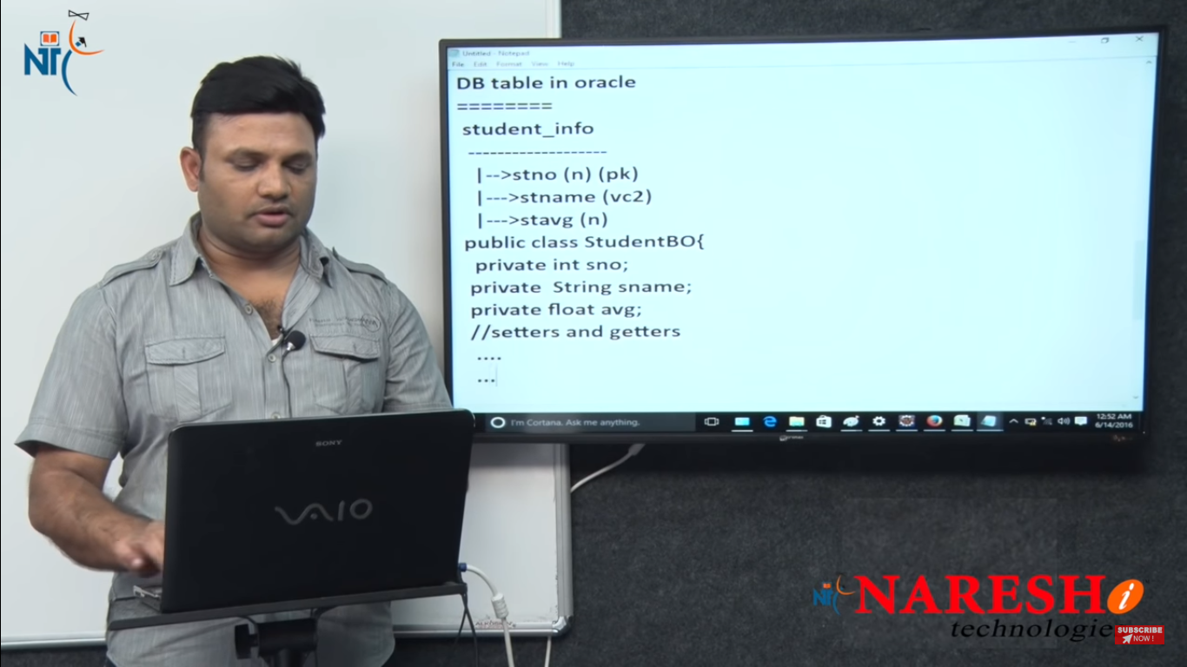

Note : A typical project conatain three thing here

Controller which recive the request and delever the response

Service class – which contains busness logic

DEo- persitance logic

Imp points:

Controller prpare VO Object , and convert into DTO object if there is any requerment that you want change data you can change Ex If we are getting some avrage mark of student 56.888% and you want save in round formatt so you can take data from VO and change and put it into DTO and send to other component,

and this DTO is pass into service class,service class use DTO as a input and convet to BO obeject and pass to DEO

and DEO use BO object as input for persitance

Note :

